”ItalianGuitar music
of 19th century:
Opera und virtuosity”

Leopoldo Saracino
Guitar

Gioachino Rossini (1792-1868)
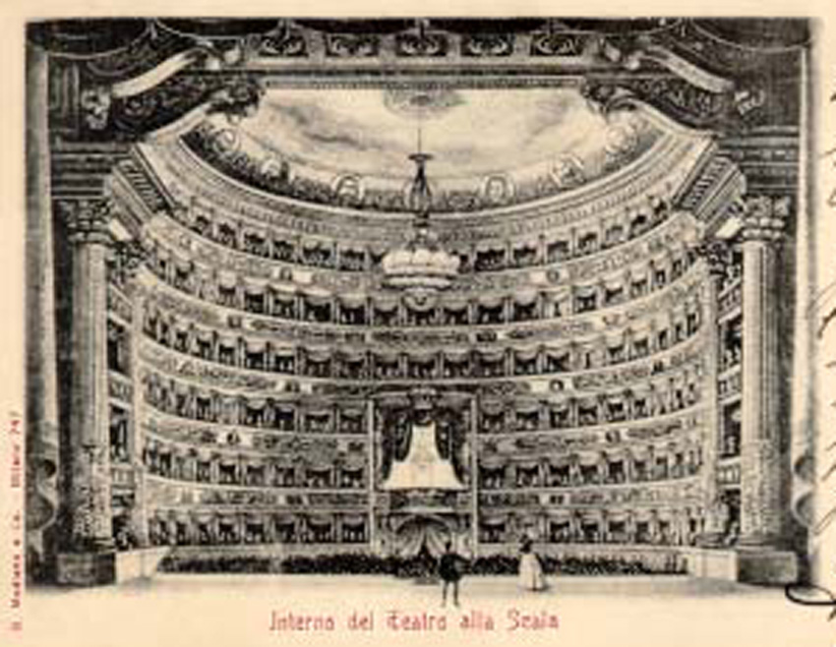
MauroGiuliani (1781-1829)
Sinfonia dell’opera
”La Cenerentola”

Mauro Giuliani
Three pieces from ”Giulianate”op.148
”Rossiniana” Nr. 5 op. 123

*************

LuigiRinaldo Legnani
(1790-1877)
6 Capricci op. 20

Niccolò Paganini
(1782-1840)
”Grande Sonata”

Sempre eran congiunti al Pesarese,
l‘uno suonando la chitarra, l‘altro il violino,
i due sublimi ingegni dell‘arte italiana,
Giuliani cioé, e Paganini”

(Giuliani and Paganini, the one on the guitar, the other on the violin, two of Italy’s greatest musicians,
they mantained frequent and close contact with the genius from Pesaro, Rossini)

This sentence from the Contestabile’s biography of Paganini gave me the idea to couple this great musician in a concert Program with the aim to evoke the musical atmosphere of the roman evenings of the 1821 in which Paganini and Giuliani were often guest in roman Rossini’s house. To these three musician I choose to put near Luigi Legnani one of the major Guitar virtuoso of the 19th Century renamed as “Paganini of the guitar” for his wonderful technical ability. Is also known that in July 1836 in Turin Paganini met Legnani and said: “Legnani is the greatest from all the guitarist”. The two became friend and planned some concert together that were possibly cancelled due to the bad health condition of Paganini.
The italian instrumental music of the 19th century was deeply influenced from the Opera and particularly from Rossini that got a great success overall Europe widening the belcanto style of the italian opera. Rossini’s great understanding of the human singing voice has a telling parallel in the innovative conception of the guitar of italian guitar virtuosi of the beginning of the 19th century.

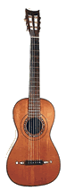

The instrument:
The period during the middle of the eighteen century saw the emergence of the
classical guitar (six-string guitar) as a development of the earlier baroque guitar (five-course guitar).
Among the foremost guitar-makers of this age were Louis Panormo.
He came from a family of Spanish makers and worked in London where he spent all his life.
The guitar of his I play has a beautiful singing, easy treble and the music fits the instrument perfectly.

